FIN.SOP.X.007
POLICIES AND PROCEDURES
Imprest Purchase Orders
(FNM/ACT)
FNM Standard Operating Procedure
Target Audience: All Staff

DISCLAIMER

Standard Operating Procedures (SOPs) provide a step-by-step guide for staff directly involved in the processing of administrative actions to support and facilitate the implementation of WHO policies and procedures. The SOPs are for guidance only; they are neither authoritative nor binding. The SOPs reflect the policies and procedures of WHO at the time of writing; however, policies and procedures change from time-to-time. In the case of a conflict between the SOPs and the WHO eManual provisions, the WHO eManual provisions take precedence.

DOCUMENT SPECIFICATIONS

Version Version | Date of revision | Author (s) / Dept / Unit | Approver | Indicate which section (s) changed compared to previous version
1.0 | June 2015 | Bahri, Sameer | Barnabe, Carmelle; BERG, Valpuri; STEWART PAPPAS, Jane Margaret; JEFFREYS, Nicholas Richard | New
2.0 | January 2016 | Barnabe, Carmelle | BERG, Valpuri; STEWART PAPPAS, Jane Margaret; JEFFREYS, Nicholas Richard | Addition of emergency procedures
3.0 | May 2020 | Afina Alagardova | Bor Florence; Berg, Valpuri | Extensive revisions regarding coding, naming convention, cash advances, etc.

Introduction

This document describes the procedures and guidelines for the use of Imprest Purchase Orders (IPOs) in compliance with the provisions in the WHO eManual (X.3.4 Imprest Purchase Orders).

General Guidance / Business Rules

The IPO provides a means to procure from local suppliers and pay directly from the Imprest account when it is impractical, not feasible, or not possible to use the regular procure-to-pay process.

Regional Budget and Finance Officers (BFOs) and the Expenditure Control and Analysis Unit (ECA) at headquarters should be consulted if any clarification is required regarding the use of IPOs.

  - Correct use of IPOs

IPOs are used to make payments under the following expenditure categories:

Expenditure Category | Description | Type of expenditure | Expenditure Type* | IPO maximum amount
General Operating Expenses (GOE) | For low-value, sundry-type expenses to support country office operations, regional offices and headquarters.  Individual payments must be less than US$ 2,500. | - office running costs such as utilities, procurement of low-value office supplies, ad hoc local transport, etc.  - hospitality (entertainment of WHO official guests)  - dispatch and courier services  - fuel and maintenance of WHO vehicles  - phone and Internet charges  - security expenses | - 519-General Op. Costs  - 520-Telecommunications  - 521-Hospitality  - 524-Security Expenses | US$ 50,000
Low value meeting and training costs | Small meetings and trainings arranged locally  Individual payments must be less than US$ 2,500. | - Training costs including rental of venue, coffee breaks, facilitation, translation etc  - Local meeting costs such as rental of venue, coffee breaks, facilitation, translation etc | - 517-Training  - 519-General Op. Costs | US$ 50,000

Expenditure Category | Description | Type of expenditure | Expenditure Type* | IPO maximum amount
Special Services Agreements (SSA) | An IPO can be established to encumber costs of SSA holders, even though GES is the recommended contract type. Refer to WHO eManual section III.16.3 Special Services Agreements for additional details on SSA arrangements | - Payment to SSA holders  - SSA holders local travel costs | - 525-SSA Expenses | US$ 200,000
Direct Implementation activities | To implement public health activities undertaken on behalf of the government, MOH, where other types of standard contracts (e.g. DFC, APW, GES) cannot be used. To release payments to large groups of beneficiaries (vaccinators, other field workers, etc.).  Refer to eManual XVI.5 Direct Implementation and FIN.SOP.XVI.002-Direct Implementation for details | - payments to field workers  - payments to participants in meetings organized locally.  - payments to security forces providing security support during field activities. | - 527-Direct Implementation
Field Operations/Offices (no GSM) | Post facto recording of field office expenses: When WHO operates in remote areas where expenses cannot be recorded in GSM in real time, jounalization vouchers are recorded periodically in the Imprest module based on submission of expenditure reports. | - office running expenses | - 517-Training  - 519-General Op. Costs  - 520-Telecommunications  - 521-Hospitality  - 524-Security Expenses | US$ 200,000

Expenditure Category | Description | Type of expenditure | Procurement  Type* | IPO maximum amount
Payments to Interns | Intern stipends and other related costs |  | 513-Contractual Serv, General | US$ 200,000
STRICTLY for DPR Korea ONLY | Salary payments to local staff STRICTLY for DPRK ONLY | local staff costs | 513-Contractual Serv, General
* Expenditure types are automatically populated into PTAEO details in the procurement registration page based on the combination of Major and Minor service categories selected for the deliverables.

IPOs must not be used for:
    - Expenditures that pertain to expenditure types not mentioned above cannot be encumbered through an IPO.
    - Procurement of goods (except for procurement in emergency settings).
    - Travel expenses (except for SSA in-country travel and payments to participants in meeting organized locally), the travel module in GSM should be used instead.
    - Office rent (LOA non-grant contract type should be used instead).

  - Creation of an IPO in GSM

When raising an IPO, please note the following:
    - IPOs (in particular for sundry-type general operating expenses) should be established at the beginning of the year for a duration of 3 months to one year (or award end date or year-end date, whichever is earlier). The Major Office to which the Country Office reports sets the appropriate duration of the IPOs in the Region. The total purchase order amount assigned to the IPO for general operating expenses is based on an estimated budget breakdown of costs for the intended period.
    - The contract type ‘Imprest/Credit Card’ is selected when raising the Purchase Requisition (PR) in GSM using the Procurement Requestor responsibility.
    - Under the section “Agreements Details”, a generic supplier name is selected based on the Major Office under which the country creating the IPO is located: (e.g. for EMRO, “EIMPREST–EMRO” is selected as a supplier).
    - The drop-down menu in the supplier site field will display the list of existing Imprest accounts for the region
    - The currency selected in the “Amount and Planned Payment” section should match the currency of the selected Imprest account.
    - The “Short Description” field for all IPOs should define the nature and purpose of the expenditure.
    - “Amount-based” option is selected as well as “Maximum amount”.
    - A budget to support the encumbered amount must be attached in ECM before the PR is submitted for approval (template available in section 4.3. The corresponding document type is “Contractual-Budget Breakdown”
    - There should be one deliverable line (under section “Deliverables and Planned Payments”) and the deliverable type should be ‘Others’. (DI IPOs are an exception to the one deliverable rule and are established with two deliverables. Refer to WHO eManual section XVI.5 Direct Implementation and FIN.SOP.XVI.002-Direct Implementation for details).
    - When inserting PTAEO details for deliverables, users select the appropriate Major and Minor service categories based on the nature of the expenditure (Refer to WHO eManual section XII.5.2 Expenditure Recording and “Service category Matrix” available on the Accounts Intranet site under the header ‘Expenditure Recording’: http://intranet.who.int/homes/act/pol/).
    - An IPO can be created with multiple PTAEOs.
    - Adjudication reports and Contract Review Committee approval are not required for IPOs.

  - Payments

    - Payments from an Imprest account are made against an approved IPO, a payment instruction (PI) received from GSC, or exceptionally authorized by the Head, ECA (HQ) or Regional Budget and Finance Officer.
    - Unlike other PO types (APW, GES, non-grant LOA, DFC etc.) payments against IPOs do not require to record the receipt of a deliverable.
    - To generate a payment against an existing IPO, a voucher must be prepared: in GSM main Menu, under eImprest select Payments/PO Imprest
    - Payments against an IPO should only be made to local suppliers, and for activities/ the purpose for which the IPO was established.
    - Disbursements from local Imprest accounts should be made through bank transfer or bank cheque. Cash payments should only be made in exceptional circumstances when bank transfers or bank cheques are not possible or for low value CO sundry expenses.
    - Salary advances and travel advances for staff members holding a travel request may only be processed based on a Payment Instruction (PI) from GSC and may not be encumbered through and paid against an IPO.
    - Payments under an IPO must be made directly to the supplier named on the invoice or to the end beneficiary. Payments to third parties are not allowed but they can be exceptionally approved when operational circumstances do not allow for payment directly to the bank account of the named supplier. Such exceptions must be requested in writing by the named supplier or the responsible administrative authority of the supplier (refer to WHO eManual section section X.2.1. 100).
    - When payments are issued by cheque or cash, the recipient (who must be either the final beneficiary or his official representative) is required to sign the Imprest voucher. A copy of the external payee’s passport or other valid photo identity document must be attached to the payment voucher as evidence that the payment was made to the correct individual.
    - All transactions initiated at the local level must be accompanied by an Imprest voucher, signed by the initiator and the approving officer (the approving officer is either the Imprest Holder or an authorized responsible staff member as designated by the Imprest Holder). Payments may only be made based on acceptable and adequate supporting documents (original invoices, reports, delivery reports, certification of receipt of services, etc.) duly certified by the designated officials.

  - Payment category and use of supplier name on the Imprest vouchers

    - As a rule, the supplier name on the Imprest voucher must be the supplier name indicated on the corresponding invoice or the final beneficiary.
    - When individual payments not exceeding USD 2,500 each are made to large groups of beneficiaries (vaccinators, field workers) through bank transfers, distributions at the bank counter or mobile banking, a “group voucher” can be issued. The bank will distribute the payments based on a list of beneficiaries included in the payment instructions.
    - When the payment to an individual beneficiary exceeds US$ 2,500 (or local currency equivalent) it cannot be included in a “group voucher”. A separate voucher must be prepared to clearly identify the final beneficiary of any payment exceeding US$ 2,500.
    - When creating an Imprest voucher, one of the four available payment categories is selected. The table below provides guidance for selecting the category and entering the supplier name on the voucher:
Payment category | To be used | Supplier name to be entered
Final beneficiary | - For payments to local vendors  - For SSAs  - For DI final beneficiaries  (up to max. USD 2,500) | - Official name of the company, if the recipient is a company  - Last name first name, if the recipient is an individual
Bank list | when an Imprest voucher is raised to pay a group of final beneficiaries (field workers under direct implementation or SSAs) through the bank and none of the individual payments exceeds US$ 2,500 | - Official name of the bank
Operational advance | When an Imprest voucher is raised to pay a group of final beneficiaries (field workers under direct implementation or SSAs) through an operational advance under the custody of a WHO staff and none of the individual payments exceeds US$ 2,500 | - Last name first name, of the operational cash advance custodian
Field office expenses | when the Imprest voucher is raised for field office journalization vouchers and none of the payments to the final beneficiaries exceeds USD 2,500 | - Field office expenses

  - Operational advances – NOTE! NEW SECTION / POLICY ON OPERATIONAL ADVANCES!

In exceptional circumstances, when it has been established that no other payment modality can be used, a WHO staff member may be allowed to deliver and distribute payments to final beneficiaries. This can only be authorized after more secure alternative solutions have been explored and ruled out. As a rule, cash disbursements must be processed by payment services providers (banks, micro-finance institutions, money-transfer companies, post offices, mobile money payments providers…) that can be engaged to deliver and distribute cash payments based on WHO CO’s authorization and instructions. In each country, specific solutions offered by local banks and/or other financial third parties must be considered: For instance, payments distribution through prepaid cards or mobile phones should be prioritized when available. WHO COs should also explore solutions adopted by other UN organizations operating in the same country/location.

Operational advances may only be used to pay a group of beneficiaries (field workers, participants to local meeting, security personnel under direct implementation) where none of the final beneficiaries receive more than US$ 2,500. During graded emergencies, operational advances can also be used for local procurement.

- Please note! Operational advances rules do not apply to low value CO sundry expenses that are paid from the Imprest cash account/petty cash.

Operational advance approval:
Advances up to USD 20,000 are approved by the WR. If the operational advance exceeds USD 20,000, DAF approval must be obtained in writing and the approved request must be attached to the voucher in GSM. The request must specify the need, the justification for the chosen payment modality and provide details on security arrangements.

For all advances of more than USD 500, the Operational Advance Custodian Appointment form should be filled and signed jointly by the WR and the custodian of the advance. The form is then uploaded to GSM with the corresponding voucher (template available in section 4.3).

Custodian of Operational Advance: The Custodian should be a WHO staff member. When no staff is available to take on the role of Custodian, SSAs employed for country office work can exceptionally also receive operational advances.

Operational advance recording: All advances must be recorded and monitored in the operational advances SharePoint https://workspace.who.int/sites/OPADV/SitePages/Welcome.aspx.
Regional BFOs to decide whether the operational advances are recorded directly at the country office (recommended, to avoid duplication and to have real-time visibility of advances globally) or at Regional office level based on monthly imprest reporting. Access requests should be made by the BFOs to HQ/BOS/FNM/ECA.

Payment modality: The advance must be withdrawn from the CO Imprest bank account (not from the Imprest cash account/petty cash that may only be used to pay for low value CO sundry expenses) through check or instruction to the bank to pay the custodian. The funds may not be transferred to the custodian’s personal bank account. If the custodian needs to travel, it is recommended to withdraw the funds from a bank branch at the final beneficiaries’ location.

Number of cash advances: Only one unliquidated advance per custodian is allowed at any given time. No new advance can be issued to an individual with an outstanding advance.

Operational advance liquidation time: 30 days

Voucher creation: the supplier name indicated on the Imprest voucher must be that of the custodian of the operational advance (Last name/ first name). The payment category to be selected must be ‘Operational Advance’.

Liquidation process: The OO/AO reviews the liquidation file provided by the custodian that includes the original vendor invoices and payment receipts, the distribution lists signed by the final beneficiaries, the liquidation report that includes the reconciliation between the advance amount and the balance returned to the CO. The OO/AO will then sign the liquidation report (template available in section 4.3).
In case of refund (partial or total), a credit memo is established (in GSM Main menu under eImprest select PO Imprest, in the transaction type field select Credit Memo – Imprest PO).
The liquidation is recorded in the Operational Advances SharePoint.

  - Documentation Requirements

    - Each IPO must be supported by signed documentation such as a contract and/or an estimated budget breakdown that is uploaded into ECM at PO initiation. Refer to Section 4.3 for a sample budget template.
    - When the IPO pertains to the salary costs of one or multiple SSA holders, a duly approved memo, or spreadsheet, or other suitable documentation which includes the name of the SSA holder(s), the duration of the contract(s), and an estimated budget of the remuneration to be paid to the SSA holder(s) must be uploaded into ECM at PO initiation.
    - COs/ROs must maintain a system to keep track of all SSA contracts and to ensure that all SSA holders were actually employed for the duration of their contracts.
    - SSA salary payments must be supported by a signed Imprest voucher and payroll/salary spreadsheets/attendance reports.
    - Payments for SSA in-country travel must be supported by a signed Imprest voucher, original invoices from the travel agency as well as a breakdown of the per diem paid (according to applicable official per diem rates).
    - All payments made locally against IPOs must be in line with the purpose for which the IPO was established and must be supported by:
      - original documentation such as supplier invoices, delivery reports, certification of receipt of services, etc.,
      - proof of payment such as an official receipt from a supplier or
      - supplier signature on the Imprest voucher, for payments by cheque or cash made in person to the supplier.
    - All original documentation (IPO approval documentation, IPO budgets, supplier invoices, payment confirmation, etc.) are retained at the Country Office.
    - Refer to WHO eManual section XVI.5 Direct Implementation and FIN.SOP.XVI.002-Direct Implementation for additional documentation requirements associated with DI IPOs.

  - Cancellation, Closure, Refunds

When no implementation against the IPO has occurred and funds have not been disbursed, the IPO should be cancelled.

IPOs should not be closed until all operational advances have been liquidated, reports from the payment services providers are cleared and the related refunds are received and recorded. In addition, the receipt of an approved DI FACE Report and technical report is required. Refer to FIN.SOP.XVI.002-Direct Implementation.

GSC will automatically close IPOs (except DI POs) when the following criteria are met:
- PO remains open more than 3 months after the award end date; or
- Full payments have been made and the remaining balance on the PO encumbrance is zero
This process is run monthly to finally close such POs. Refer to Information Note: 21/2018 – Procurement – Final Closure of Purchase Orders (PO)

At the end of each biennium, all Imprest POs are closed as per the year-end accounts closure time table (before closure of the GSM PO module, normally second week of January.

  - Use of Imprest Purchase Orders in graded Emergencies

Per section 2.1 above, IPOs may be used in graded emergencies to procure from local suppliers. The Regional Budget and Finance Officer (BFO) or the Expenditure Control and Analysis Unit (ECA) at headquarters should be consulted if any clarification is required regarding the use of IPOs in emergencies.

Applicability

When a graded emergency has been declared and when it is determined that 1) it is impractical, not feasible, or not possible to use the regular or emergency procure-to-pay process and 2) normal bank systems are not available or functional, IPOs may be established to make local emergency purchases. When these criteria are met, the following IPO guidelines apply:
- One Blanket IPO up to US$ 200,000 may be established to encumber funds for □services procurement and □goods procurement. (One IPO for each, in other words a total of two blanket IPOs)
- Should it be necessary to establish more than one blanket IPO for program related operating expenses or goods, approval must be received in advance from the DAF or the Chief WRE/SHO. Evidence of this approval (memo or email) must be uploaded to the ECM when the IPO is being raised.
- During emergencies, the requirement for a budget is waived, but a note in the 'detailed description' field in the Purchase Requisition (PR) is required indicating
- that the activity pertains to a graded emergency;
- which emergency and grade;
- why IPO instead of 'normal' procurement is being used; and
- a short description of the anticipated expenses.
- During emergencies, the creation of the IPO in GSM can be expedited through a request in MyService. The box “officially declared emergency” should be ticked and one of the emergency reasons should be selected from the drop-down menu.
- If procurement/payments for emergency activities are required immediately and the IPO to encumber funds for this activity is not yet available in GSM, the transaction can temporarily be charged directly to a PTAEO, using the transaction type “PTAEO” in eImprest. Once the IPO for the emergency activity has been created, an entry must be recorded to reverse the PTAEO transaction and a new entry created to record the activity to the appropriate IPO. This option is strictly exceptional and these transactions must be monitored monthly and reversed on a timely basis.
- The maximum duration of an emergency IPO is one year (or award end date or year-end date, whichever is earlier).
- In graded emergencies only, the individual transactions/payments may be made up to the total purchase order amount and are not limited to the US$ 2,500 (or local currency equivalent).

Authorized expenses
In addition to the authorized expenses in section 2.1, in graded emergencies, Imprest POs can also be used as described below:
Expenditure Category | Expenditure description | Expenditure Type* | IPO maximum amount
Program related operating costs | - transportation of people and goods  - vehicle rental  - fuel for vehicle used during the implementation of field activities.  - renovation and construction costs of health facilities  - Customs clearance costs/ demurrage relating to emergency goods importation | - 513-Contractual Services, General | US$ 200,000
Local procurement | - medical supplies and consumables  - vehicle, equipment and furniture  - equipment for 3rd parties | - 514-Med. Supplies, Literature  - 515-Equip, Veh, Furniture  - 555-Equip for third parties | US$ 200,000

In very exceptional situations when the contract is not yet available, and work of consultants and other HR must commence immediately, payments can be made through IPO upon receiving exceptional approval from Regional HR manager/DAF (with appropriate approving memos). Otherwise, salary payments are not permissible under a blanket IPO.
The local procurement of pharmaceuticals, vaccines and biologicals is not permissible through IPOs unless prior agreement has been obtained from Procurement Officer either in Regional Office or HQ.

In cases where suppliers have requested cash payment, an arrangement must be established for suppliers to collect cash payment based on a payment instruction. The bank must note Name, ID, and other relevant information (as agreed between WHO and the bank providing this service) of individuals who collect cash and provide this information back to WHO for reconciliation purposes. A log of all such payment instructions must be maintained and reconciled weekly with the information provided by the bank. This log must be included in the monthly Imprest return submitted to the regional office

Operational Advances in graded emergencies

WHO staff, consultants, and SSA Holders may require cash to assist in the set up and maintenance of emergency response operations in the field when regular payment mechanisms are not available or where the local infrastructure has been severely damaged. In these cases, the WHO staff, consultant, and/or SSA holder may be granted an emergency operational advance (that may be withdrawn from the Imprest Cash account) to facilitate the necessary activities. If cash advances need to be paid to recipients other than these, approval from the Regional Budget and Finance Officers or the Regional Director of Administration and Finance should be obtained up front.
Operational advances in emergencies can be used to pay groups of field workers as well as for local procurement.
Other rules related to operational advances (refer to 2.5) presented above apply to operational advances in emergencies.

Monitoring

At the country level:
- The Imprest Holder, who is responsible for the Imprest account and all funds under his or her responsibility, must ensure that all IPOs and all transactions charged to IPOs are compliant with WHO’s rules and procedures and that IPOs are closed on a timely basis and before the award close date.

At the regional level:
- The Budget and Finance Unit or Compliance Unit reviews IPOs issued on a spot check basis (post PO creation) to ensure that supporting documentation is attached to the Imprest payment voucher and that the expenditure and reporting are in accordance with WHO’s rules and procedures.

At headquarters:
- Direct Implementation monitoring reports and Imprest monitoring reports are periodically generated and shared with the Regions so that compliance with these SOP guidelines can be evaluated.

Reference Material

    - WHO eManual
- X.3 Imprest
- XII.15 Expenditure Recording
- XVI.5 Direct Implementation
- III.16.3 Special Services Agreements
- XVII.6.3 Cash Advances in Emergencies
- XVII.6.3 Imprest Purchase Orders (in Emergencies)

    - Related SOPs
- PRT.SOP.VI.001 Service Requisition Validation | - FIN.SOP.XVI.002-Direct Implementation
- PRT.SOP.VI.002 Service PO Distribution | - PRT.SOP.VI.056 Service Emergency Procurement
- PRT.SOP.VI.005 Service PO Cancellation | - FIN.SOP.X.008 Cash Advances in Emergencies
          - PRT.SOP.VI.055 Services Requisition

    - Templates and forms:

IPO budget template | Operational Advance Custodian Appointment form (English) | Operational Advance Custodian Appointment form (French) | Operational Advance Liquidation Report (English) | Operational Advance Liquidation Report (French)

- PROCESS FLOW

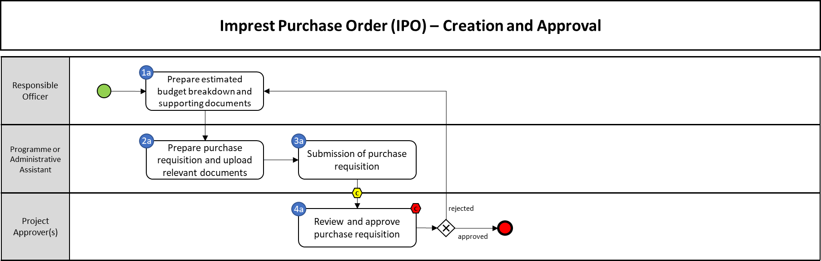

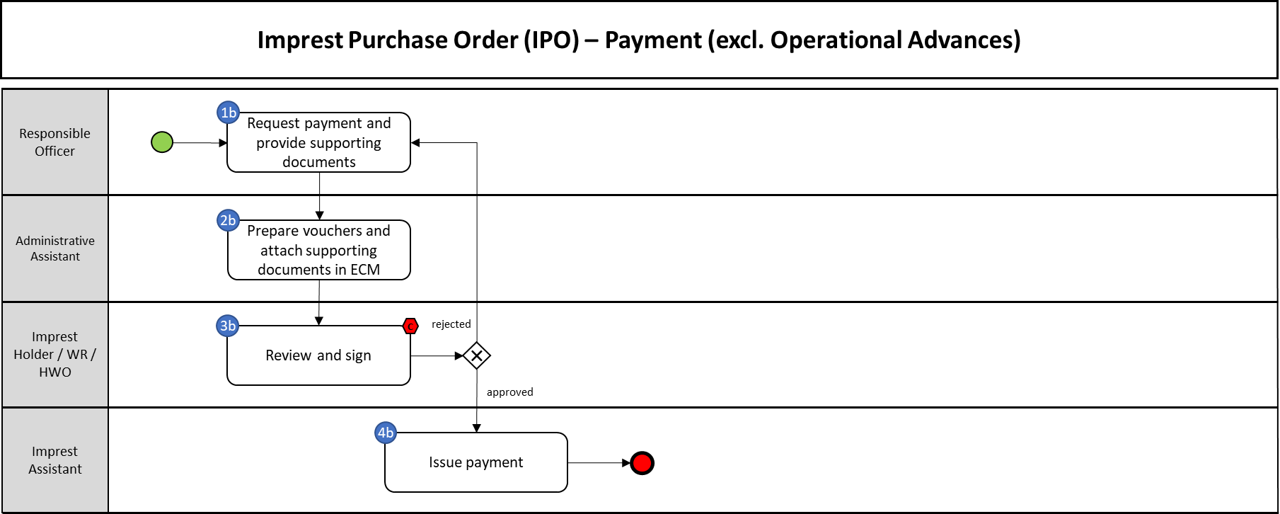

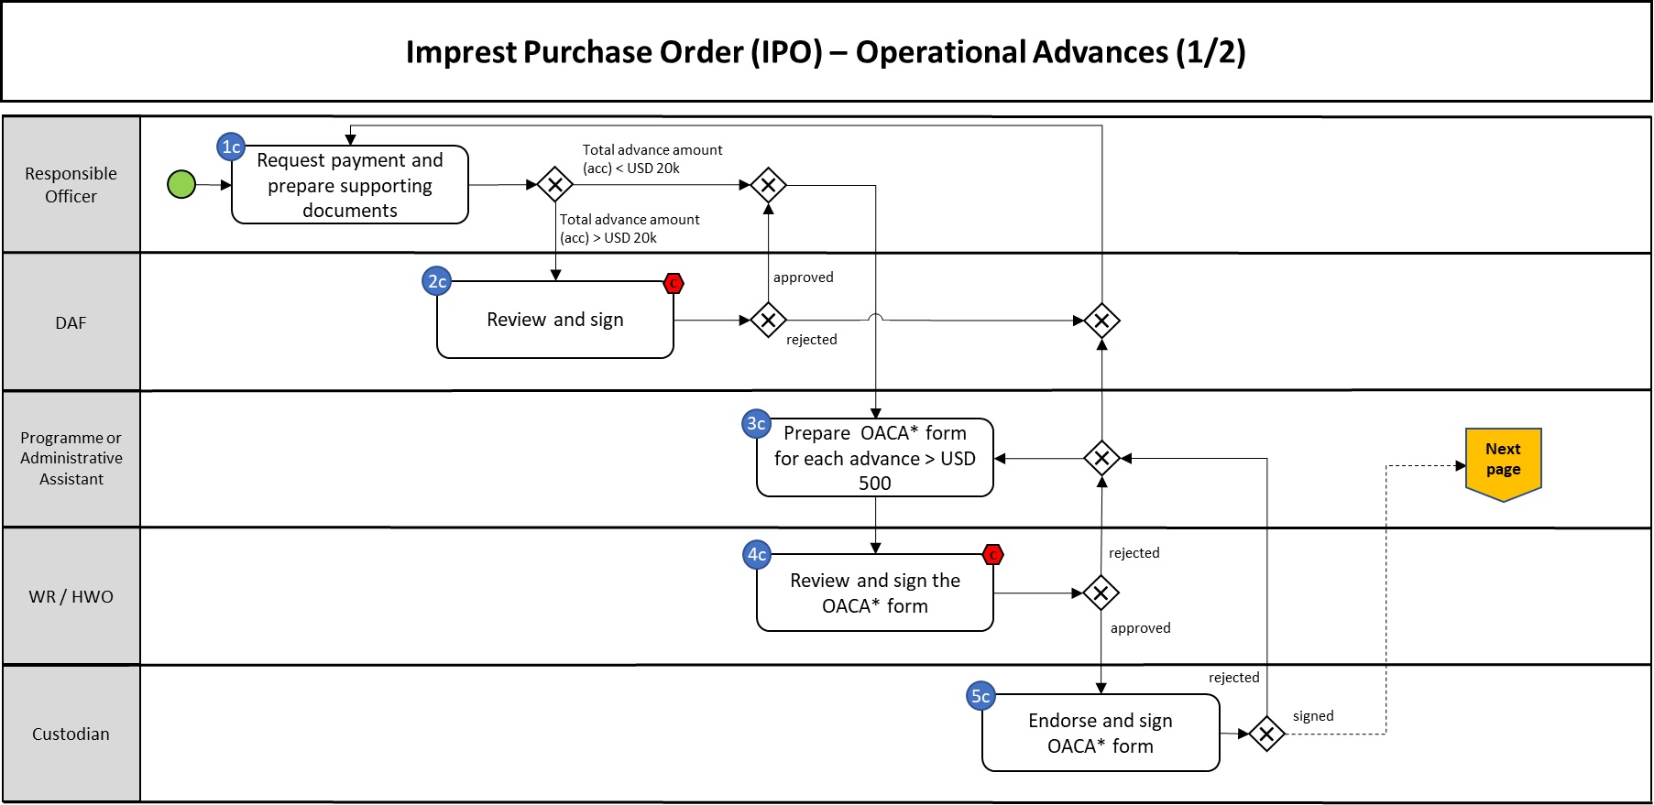

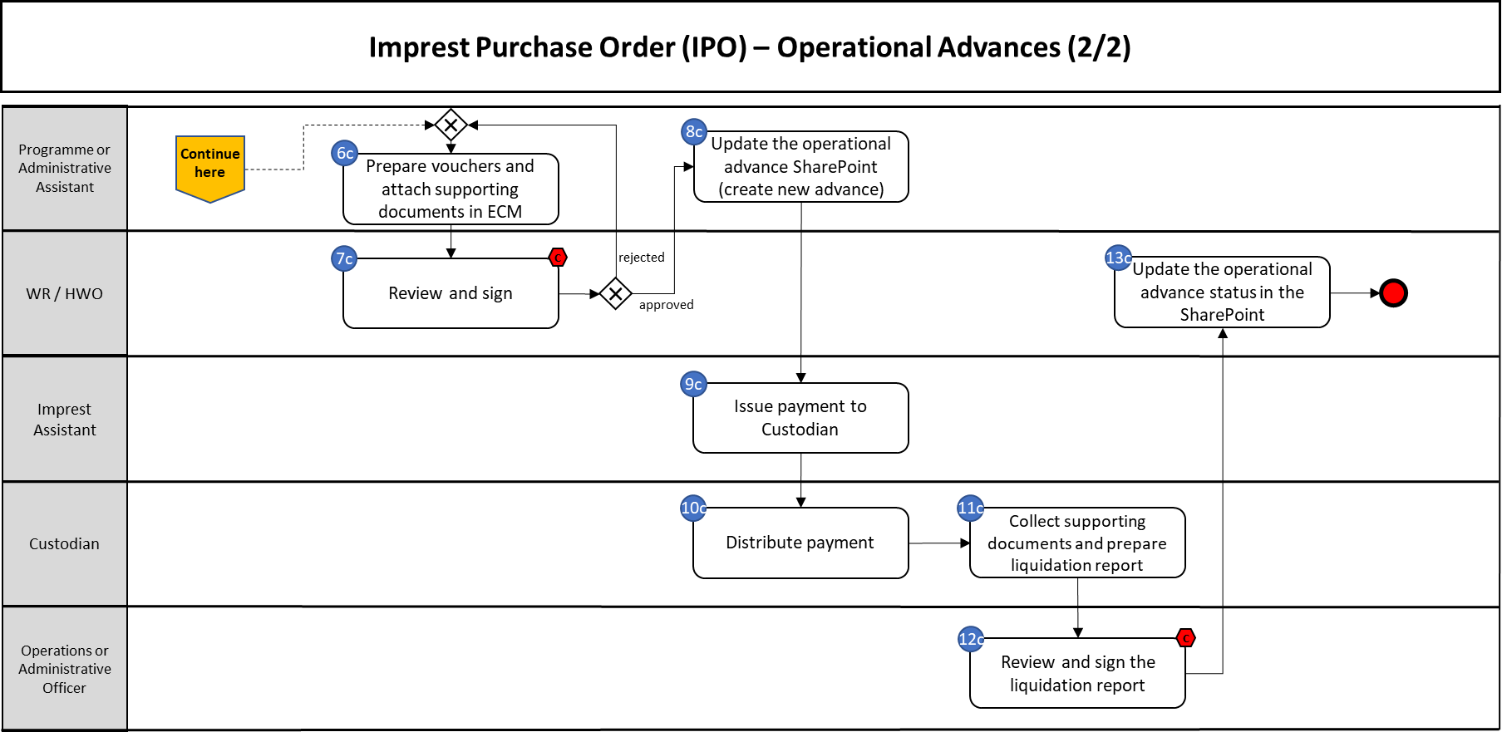
- PROCESS STEPS

Imprest Purchase Order (IPO) – Creation and Approval
# | Control | System(s) | Process step description | Role/Responsibility
1a |  | Offline | Prepare estimated budget breakdown and supporting documents | Responsible Officer
2a |  | GSM/ECM | Prepare purchase requisition and upload relevant documents | Programme or Administrative Assistant
3a |  | GSM | Submit purchase requisition for review | Programme or Administrative Assistant
 | x | GSM | Perform quality assurance pre-checks | Regional team designated by BFO*
4a | x | GSM | Review and approve purchase requisition | Project Approver(s)
*BFO decides expenditure threshold

Imprest Purchase Order (IPO) – Payment (excl. Operational Advances)
# | Control | System(s) | Process step description | Role/Responsibility
1b |  | Offline | Request payment and provide supporting documents | Responsible Officer
2b |  | eImprest | Prepare vouchers and attach supporting documents in ECM | Administrative Assistant
3b | x | Offline | Review and sign | Imprest Holder / WR / HWO
4b |  | Offline | Issue payment | Imprest Assistant

Imprest Purchase Order (IPO) – Operational Advances
# | Control | System(s) | Process step description | Role/Responsibility
1c |  | Offline | Request payment and prepare supporting documents | Responsible Officer
2c | x | Offline | Review and sign | DAF
3c |  | Offline | Prepare OACA form for each advance > USD 500 | Administrative Assistant
4c | x | Offline | Review and sign the OACA form | WR / HWO
5c |  | Offline | Endorse and sign OACA form | Custodian
6c |  | ECM | Prepare vouchers and attach supporting documents in ECM | Administrative Assistant
7c | x | Offline | Review and sign | WR / HWO
8c |  | SP | Update the operational advance SharePoint (create new advance) | Administrative Assistant
9c |  | Offline | Issue payment to Custodian | Imprest Assistant
10c |  | Offline | Distribute payment | Custodian
11c |  | Offline | Collect supporting documents and prepare liquidation report | Custodian
12c | x | Offline | Review and sign the liquidation report | Operations or Administrative Officer
13c |  | SP | Update the operational advance status in the SharePoint | Administrative Assistant

- KEY RISKS & COMPENSATING CONTROLS

Risk | Control | Process step(s)
Activities are not in line with workplan or donor agreement | Review the purchase requisition, review the detailed budget, check the workplans and awards used and approve the encumbrance | 4a
Operational advances are used for large payments while other more secured modalities should be used instead | Review operational advance justification and approve | 2c
The payment is not processed according to WHO financial rules | Review the IPO request for administrative and financial compliance, including whether offline approvals are in ECM | 3b, 7c
Payment through cash distribution while more secured payment modalities could be used. The designated custodian does not have the capacity to fulfil this assignment. The security level is not sufficient. | Review the advance justification in the OACA form, make sure that the designated custodian has the capacity to fulfil the mission and does not have other unliquidated advances. Review the security arrangements. | 4c
Operational advance not used for the intended purpose | Review supporting documents and sign off liquidation report | 12c
Incorrect use of Imprest POs | Perform quality assurance pre-checks to ensure that the Imprest PO was correctly raised in GSM, that its purpose is in line with the policy and mandatory documents are available for review | Pre-check by ACT/FNM HQ or Regional B&F teams

